**NATIONAL UNIVERSITY OF COMPUTER AND EMERGING SCIENCES**

**PROGRAM: SOFTWARE ENGINEERING**



***WEB ENGINEERING***

**ASSIGNMENT 01**

**SUBMITTED BY:**

**Name: Ahmed Ali**

**Roll No: 22P-9318**

**Section: BS(SE)-6B**

**INSTRUCTOR NAME: Sir Umer Haroon**

**A DEPARTMENT OF COMPUTER SCIENCE**

**QUESTION NUMBER 01:**

Explain what the position: relative; on the .container class does in this scenario

**ANSWER:**  
*It makes the container stay where it is but lets its children know where to start if they want to be moved using coordinates*

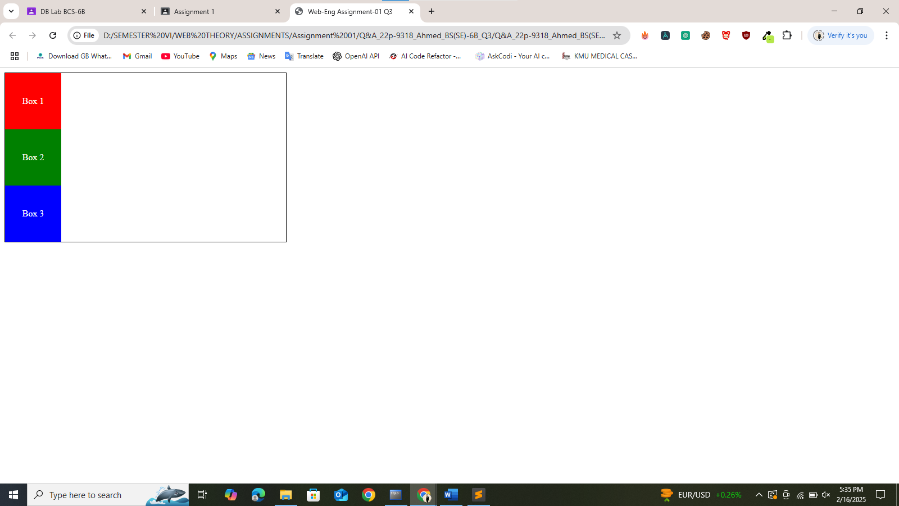

**QUESTION NUMBER 02:**

Modify the CSS to make .box1 use position: absolute; and be positioned 20px from the top and 0px from the left of the .container. Explain how the change affects the layout of the other boxes

**ANSWER:**

*Box1 moves to 20px from the top and 0px from the left inside the container because it is absolute it does not push the other boxes they stay where they are*

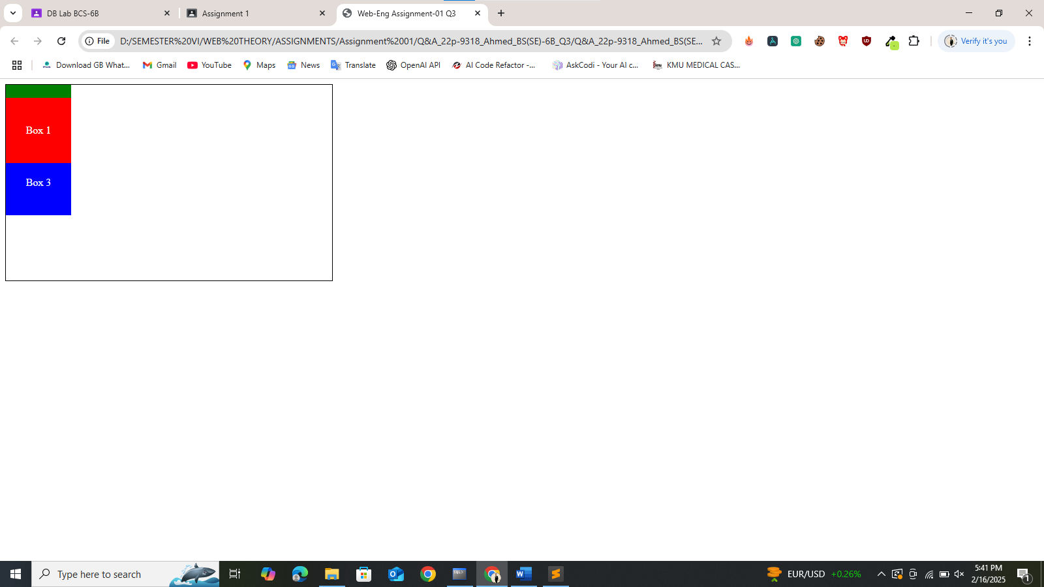

**QUESTION NUMBER 03:**

*Change the CSS for .box2 to use position: fixed; with top: 10px; and right: 10px;. Describe what happens to .box2 when the page is scrolled. Explain why this happens*

**ANSWER:**

*Box2 sticks to the screen at 10px from the top and right. It stays in the same place even if you scroll.*

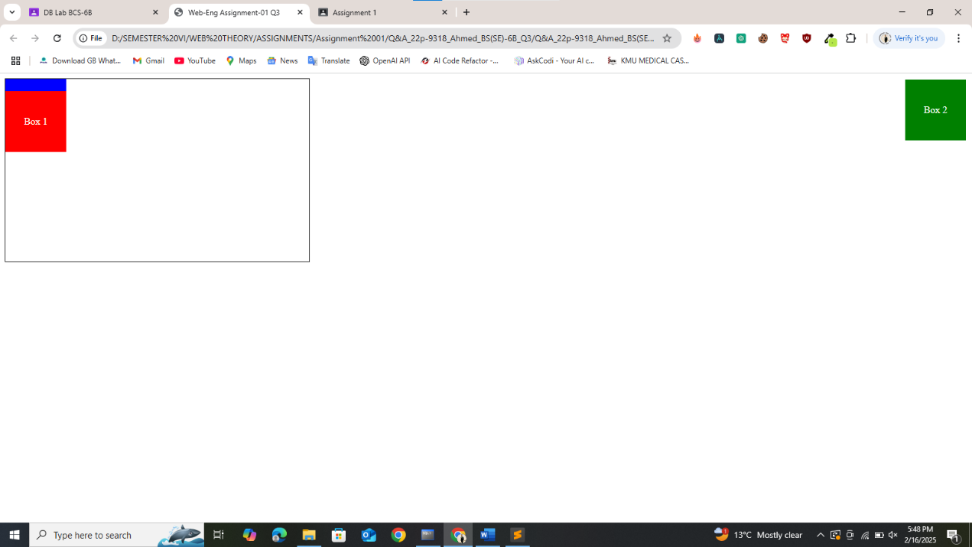

**QUESTION NUMBER 04:**

*What would happen if you removed position: relative from .container? Explain how the position of .box1 (which is position: absolute) would change*

**ANSWER:**

*Without it Box1 will be positioned relative to the whole page not the container. This place Box1 in an unexpected spot.*

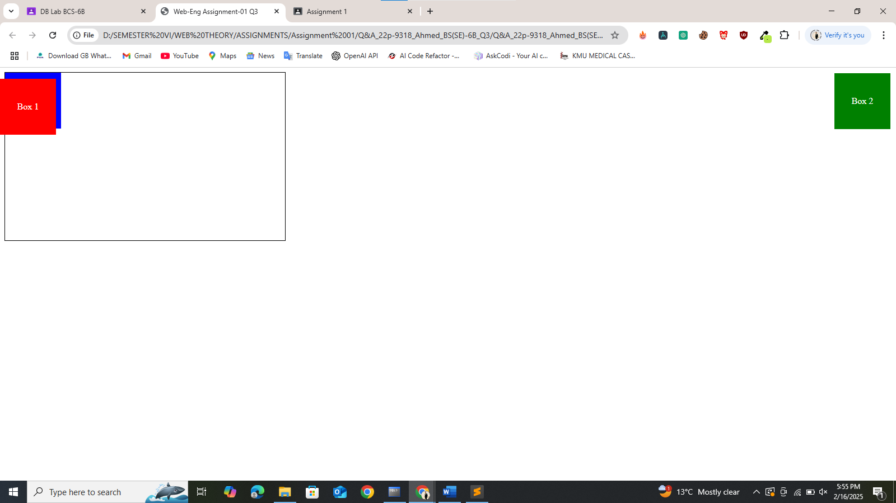

**QUESTION NUMBER 05:**

*Currently, the .box elements are display: block; by default. Add the CSS property display: inline- block; to the box class. Explain how this change affects the layout of the boxes*

**ANSWER:**

*The boxes can now sit side by side (next to each other) if there is room, while still keeping their set width and height*

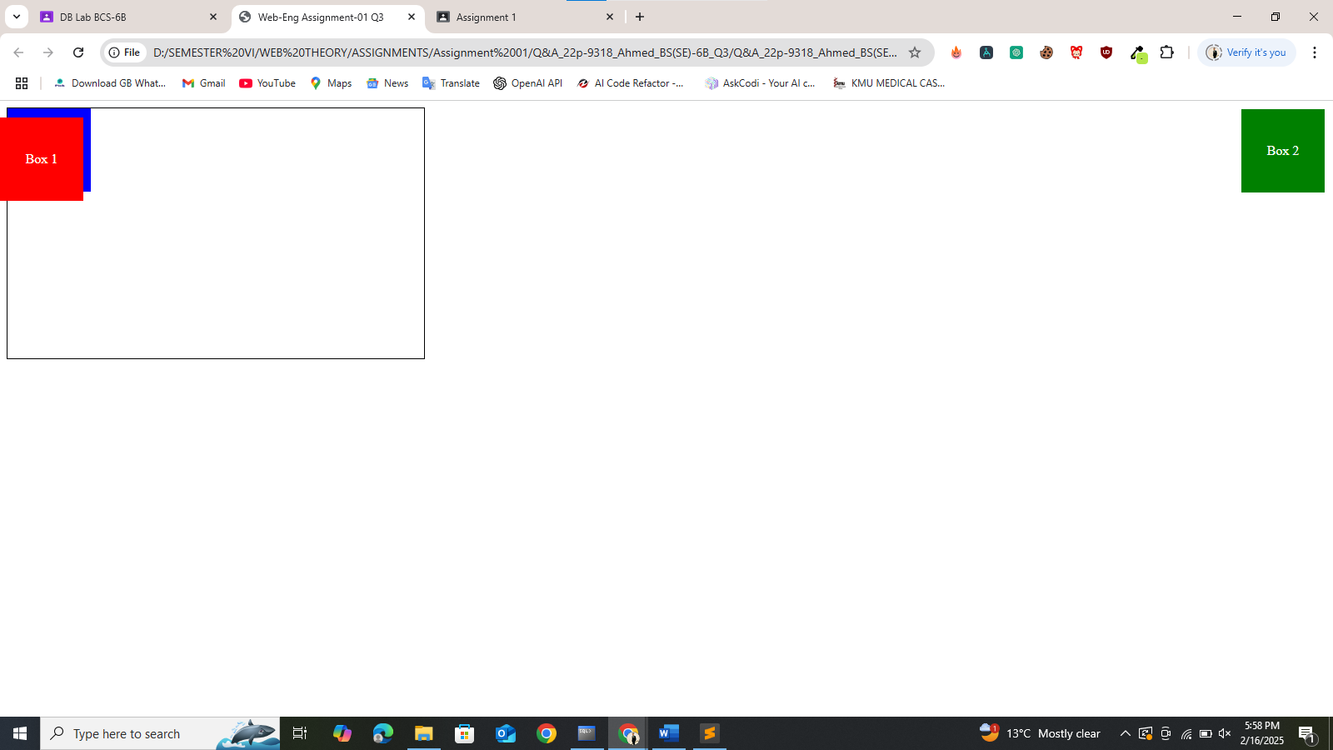

**QUESTION NUMBER 06:**

*What is the main difference between display: inline and display: inline-block? Explain with an example of how it will affect the height and width of .box elements*

**ANSWER:**

*Inline elements line up next to each other but you cannot set their width or height, Inline-block elements also line up next to each other, but you can give them a width and height*

***FINAL CODE:***

*<!DOCTYPE html>*

*<html>*

*<head>*

*<title>Web-Eng Assignment-01 Q3</title>*

*<meta charset="utf-8">*

*<style>*

*.container*

*{*

*width: 500px;*

*height: 300px;*

*border: 1px solid black;*

*position: relative;*

*}*

*.box*

*{*

*width: 100px;*

*height: 100px;*

*color: white;*

*text-align: center;*

*line-height: 100px;*

*display: inline-block;*

*}*

*.box1*

*{*

*background-color: red;*

*position: absolute;*

*top: 20px;*

*left: 0px;*

*}*

*.box2*

*{*

*background-color: green;*

*position: fixed;*

*top: 10px;*

*right: 10px;*

*}*

*.box3*

*{*

*background-color: blue;*

*}*

*</style>*

*</head>*

*<body>*

*<div class="container">*

*<div class="box box1"> Box 1</div>*

*<div class="box box2"> Box 2</div>*

*<div class="box box3"> Box 3</div>*

*</div>*

*</body>*

*</html>*

***FINAL OUTPUT:***

